**ASSIGNMENT 6--JAVA**

-RISHWANTH K C 192372025

**1)Write a Java program to create a method that reads a file and throws an exception if the file is not found**

**import java.io.File;**

**import java.io.FileNotFoundException;**

**import java.util.Scanner;**

**public class FileReadingExample {**

**// Method to read a file and throw an exception if the file is not found**

**public static void readFile(String filePath) throws FileNotFoundException {**

**File file = new File(filePath);**

**if (!file.exists()) {**

**throw new FileNotFoundException("File not found: " + filePath);**

**}**

**Scanner scanner = new Scanner(file);**

**while (scanner.hasNextLine()) {**

**String line = scanner.nextLine();**

**System.out.println(line);**

**}**

**scanner.close();**

**}**

**public static void main(String[] args) {**

**// Static file path**

**String filePath = "path/to/your/file.txt"; // Replace this with your actual file path**

**try {**

**readFile(filePath);**

**} catch (FileNotFoundException e) {**

**System.out.println("Exception: " + e.getMessage());**

**}**

**}**

**}**

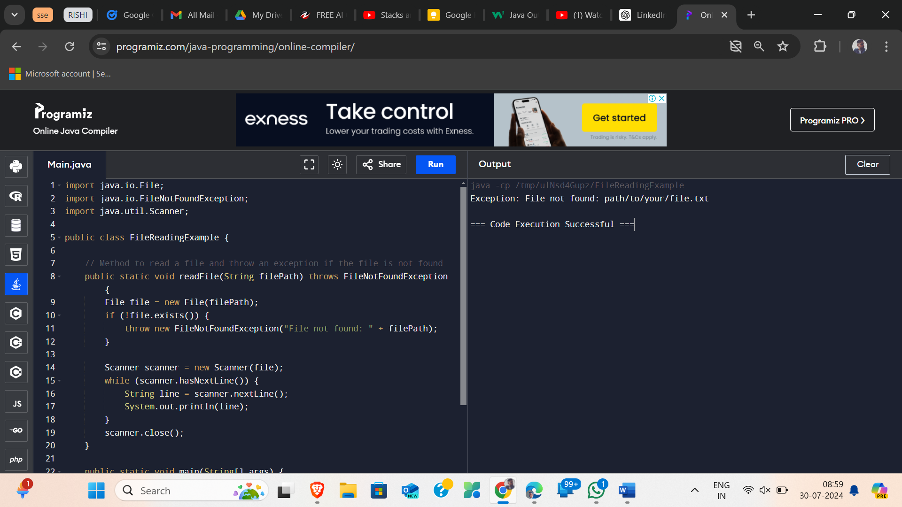

**2)Write a Java program to create a class called Student with private instance variables student_id, student_name, and grades. Provide public getter and setter methods to access and modify the student_id and student_name variables. However, provide a method called addGrade() that allows adding a grade to the grades variable while performing additional validation.**

**import java.util.ArrayList;**

**import java.util.List;**

**class Student {**

**// Private instance variables**

**private int student_id;**

**private String student_name;**

**private List<Integer> grades;**

**// Constructor**

**public Student(int student_id, String student_name) {**

**this.student_id = student_id;**

**this.student_name = student_name;**

**this.grades = new ArrayList<>();**

**}**

**// Getter for student_id**

**public int getStudent_id() {**

**return student_id;**

**}**

**// Setter for student_id**

**public void setStudent_id(int student_id) {**

**this.student_id = student_id;**

**}**

**// Getter for student_name**

**public String getStudent_name() {**

**return student_name;**

**}**

**// Setter for student_name**

**public void setStudent_name(String student_name) {**

**this.student_name = student_name;**

**}**

**// Method to add a grade with validation**

**public void addGrade(int grade) {**

**if (grade >= 0 && grade <= 100) {**

**grades.add(grade);**

**} else {**

**System.out.println("Invalid grade. Please enter a grade between 0 and 100.");**

**}**

**}**

**// Method to get grades**

**public List<Integer> getGrades() {**

**return grades;**

**}**

**}**

**public class StudentExample {**

**public static void main(String[] args) {**

**// Static input for demonstration**

**Student student = new Student(1, "John Doe");**

**student.addGrade(95); // Valid grade**

**student.addGrade(105); // Invalid grade**

**student.addGrade(85); // Valid grade**

**// Display student details**

**System.out.println("Student ID: " + student.getStudent_id());**

**System.out.println("Student Name: " + student.getStudent_name());**

**System.out.println("Grades: " + student.getGrades());**

**}**

**}**

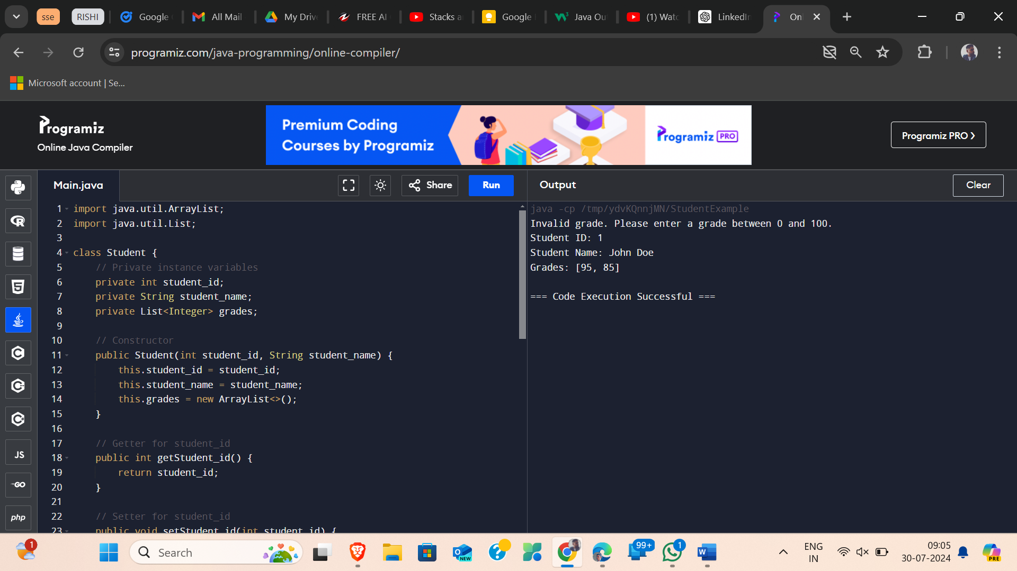

**3)Write a JavaFX application with a text input field and a button. When the button is clicked, display the text entered in the input field in a label.**

**import javafx.application.Application;**

**import javafx.scene.Scene;**

**import javafx.scene.control.Button;**

**import javafx.scene.control.Label;**

**import javafx.scene.control.TextField;**

**import javafx.scene.layout.VBox;**

**import javafx.stage.Stage;**

**public class TextDisplayApp extends Application {**

**@Override**

**public void start(Stage primaryStage) {**

**// Create a TextField for user input**

**TextField textField = new TextField();**

**textField.setPromptText("Enter text here");**

**// Create a Button to trigger the display of text**

**Button button = new Button("Display Text");**

**// Create a Label to display the entered text**

**Label label = new Label();**

**// Set the button action to display the text from the TextField in the Label**

**button.setOnAction(e -> {**

**String text = textField.getText();**

**label.setText(text);**

**});**

**// Create a VBox layout and add the TextField, Button, and Label to it**

**VBox layout = new VBox(10); // 10 is the spacing between elements**

**layout.getChildren().addAll(textField, button, label);**

**// Create a Scene with the layout**

**Scene scene = new Scene(layout, 300, 200);**

**// Set up the Stage**

**primaryStage.setTitle("Text Display App");**

**primaryStage.setScene(scene);**

**primaryStage.show();**

**}**

**public static void main(String[] args) {**

**launch(args);**

**}**

**}**

